BAHAN AJAR BRIDGING COURSE

BAHASA INGGRIS

SEKOLAH MENENGAH PERTAMA
KELAS VII

DINAS PENDIDIKAN DAN KEBUDAYAAN

KABUPATEN JOMBANG

TAHUN 2021
GREETING AND INTRODUCTION

- Listen and Repeat
Activity 1
Listen and repeat after your teacher.


Hello,
My name is Edo

Hello, I am Lisa



Good morning, Maya

Good morning, Dina.


Good afternoon, Ari.


Good Afternoon, Mr. Romi


Hi, Good evening, Mr. Heri
Hi, Good evening, Mr. Harun



Dara: Hi, Good morning. I’m Dara. What’s your name?
Saka: Hi, Good morning. I’m Saka.
Toni: Hello,my name is Toni.
Dara: Nice to meet you.
Saka: Nice to meet you too.


Activity 2
Hi, my friends. Let’s me introduce myself.
My name is Edo.
I am thirteen years old.
I live on Cempaka street Jombang.
I study at SMP Harapan.
My hobbies are cycling and reading.

Activity 3
Study the table.
Situation | Greeting | Responses
Formal | Good morning  Good afternoon  Good evening  Good day  Good night  How are you | Good morning  Good afternoon  Good evening  Good day  Good night  I’m fine, thank you  Fine, thanks
Informal | Hi, Desi  Hello, Okta  How are things? | Hi, Luki  Hello, Dania  Very well  I’m OK  Not too bad

- Let’s Practice
Activity 1
Read the conversation and perform with your friend.
- Aldo: Hi, I am Aldo. What’s your name?
Ariel: Hi, my name is Ariel. I’m a new student here.
How do you do, Aldo.
Aldo: How do you do Arief.
Nice to meet you.
Ariel: Nice to meet you, too.

2. Sari: Good morning. My name is Sari
Lala: Good morning. I’m Lala. This is my friend, Dara.
Sari: Hi, Dara.
Dara: Hi, Sari. I’m glad to see you.
Sara: I’m glad to see you too.

- Mira: Hello, my name is Mira. My complete name is Miranda ayu.
Doni: Hello. I’m DoniIriawan. You can call me Doni.
Mira: How are you, Doni.
Doni: Fine, thanks. And you?
Mira: I’m very well. Thank you.

4. Amanda: Good afternoon, Mr. Ridwan.
Mr. Ridwan: Good afternoon, Amanda.
Are you a new student here?
Amanda: Yes, Sir.
Mr. Ridwan: Oh, I see. Be a good student.
Amanda: I will, Sir.

- Let’s Try
Activity 1
Complete the dialogue.
- Tiara: Hi, Rama.
Rama: ………, Tiara. How are you?
Tiara:.………

- Sinta: Good morning, I’m Sinta. What’s your name?
Maria: ….
Sinta: Nice to meet you.
Maria: ……….

- Teacher : …………, class.
Students : Good morning. Sir.
Teacher : ………………… this morning?
Students : We are fine, thank you.

- Susan : ………, Sir
Mr. Roy : Good evening, Susan. Are you a new student?
Susan : Yes, I am.\
Mr. Roy : I am glad to see you.
Susan : ………

- Anita : Good afternoon, Mrs. Susi
Mrs. Susi : ………………… How are you?
Anita : I am fine, thanks. ……………..?
Mrs. Susi : ……………… Thank you.

THINGS AROUND US

A. Listen and Repeat
Activity 1
Things at school and in our house

Listen and repeat after your teacher.
(Simak dan tirukan gurumu!)
It’sa table.

Example :

What is it?

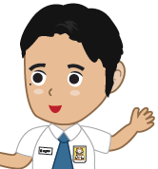

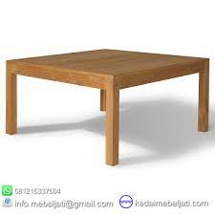

HAIDA AZWAR

1 |  | pencil | 6 |  | book
2 | 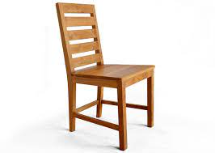 | chair | 7 | 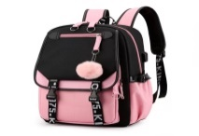 | bag
3 | 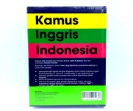 | dictionary | 8 | 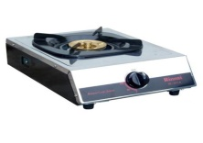 | stove
4 |  | sofa | 9 | 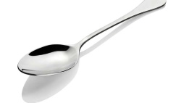 | spoon
5 | 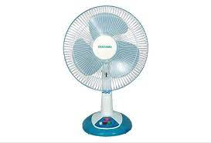 | fan | 10 |  | umbrella

Activity 2
Things around us
Listen and repeat after your teacher.
(Simak dan tirukan gurumu!)
It is a cat
Example :
What is it?



HAIDA AZWAR

1 |  | apple | 6 |  | mango
2 |  | cabbage | 7 |  | mushroom
3 | 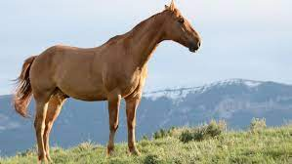 | horse | 8 |  | rabbit
4 |  | bicycle | 9 |  | car
5 | 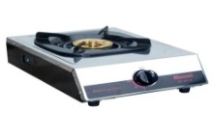 | stove | 10 | 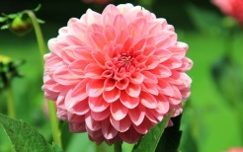 | flower

Activity 3

Cardinal Number
Listen and repeat after your teacher. (Simak dan tirukan gurumu!)

Example :
What number is it ?
One.
It is number one

1

HAIDA AZWAR

Numbers

1 | One | 11 | Eleven
2 | Two | 12 | Twelve
3 | Three | 13 | Thirteen
4 | Four | 14 | Fourteen
5 | Five | 15 | Fifteen
6 | Six | 16 | Sixteen
7 | Seven | 17 | Seventeen
8 | Eight | 18 | Eighteen
9 | Nine | 19 | Nineteen
10 | Ten | 20 | Twenty

Activity 4
Ask and answer. ( bertanya dan jawablah! )

There are three apples
Example :
How many apples are there?

HAIDA AZWAR

 | One rabbit |  | two rabbits
 | One potato |  | Three potatoes
 | One chair |  | Four chairs
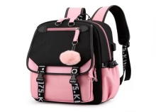 | One bag |   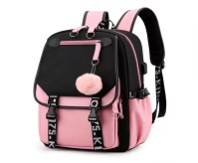 | Two bags
 | One umbrella |      | Three umbrellas

B. Let’s Practice
Activity 5
Listen to your teacher. Point to the correct pictures.
(Simaklah gurumu! Tunjuklah gambar yang benar!)

1 | There are three bananas
2 | There are seven potatoes
3 | There are five pencils | 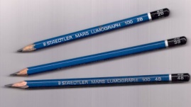 |  | 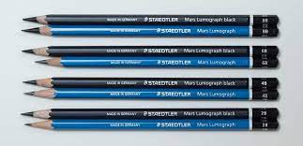
4 | There is a dog |  |  | 
5 | There are nine rosses |  |  | 

C. Let’s Try
Activity 6
Look at the picture and write sentences.
(Lihat gambar dan tulislah kalimat!)
Write the names of the fruits and the numbers.
(Tulis nama buah dan jumlahnya!)

1. There are two apples.
2. …………………
3. …………………
4. …………………
5. …………………
6. …………………
7. ………………

Activity 7
Listen and practice.
(Simak dan praktikkan!)
There are fruits
What are there in the bowl?

HAIDA AZWAR

Are there any apples in the bowl?

No, there are not.
Are there any bananas in the bowl?

Yes, there are.

HAIDA AZWAR
How many bananas are there?

There are two bananas

Activity 8
Mention the vegetables in the basket. Answer
the questions. (Sebutkan sayuran-sayuran di
keranjang!Jawab pertanyaan-pertanyaannya!)

• How many carrots are there?
• Is there any eggplant in the basket?
• How many corns are there in the basket?

Activity 9
Mention the fruits in the basket. Answer the questions.
(Sebutkan buah-buah di keranjang! Jawab pertanyaan-pertanyaan berikut!)
• How many oranges are there?
• Are there any bananas in the basket?
• Are there any watermelons in the basket?
• How many apples are there in the basket?

PEOPLE’S APPEARANCE
(PENAMPILAN ORANG)
We can say about appearance based on gender, age, general appearance, height, and weight. (Kita bisamengatakantentangpenampilanberdasarjeniskelamin, umur, penampilansecaraumum, tinggi, dan berat) badan.

Look at these pictures and read the information next to them.
(perhatikangambar-gambarberikut dan bacainformasi di sampingnya)

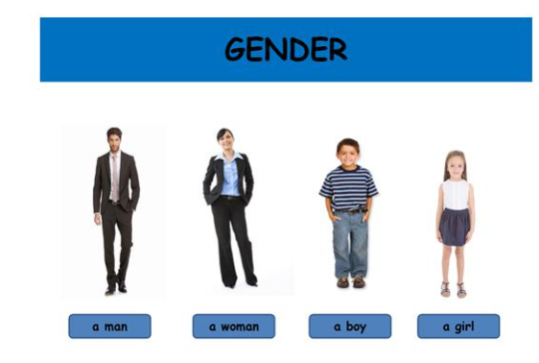 | Gender: JenisKelamin  Laki-laki : Male  Perempuan : Female
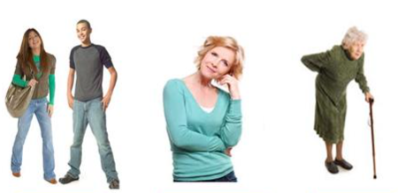 | Age: Usia  Young :muda  Middle Aged :setengahtua  Old :Tua
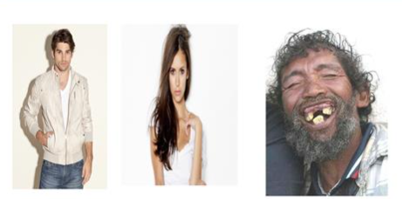 | General Apperance:  (Penampilansecaraumum)  Handsome : Tampan  Beautiful :cantik  Ugly :jelek
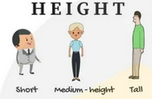 | Height: Tinggi Badan  Tall :tinggi  Medium height :sedang  Short :pendek
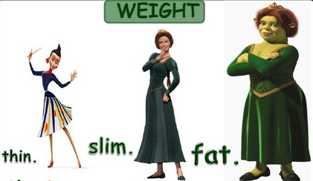 | Weight: Berat badan  Fat :gemuk  Slim :langsing  Thin : kurus
Exercise 1 Look at these pictures. What can you say about these people?
(Perhatikangambar-gambarberikut. Apa yang bisa kalian katakantentang orang-orang ini?)
Now, fill in the blank spaces with suitable words.
Sekarang, isilahtitik-titikberikutdengan kata-kata yang sesuai.
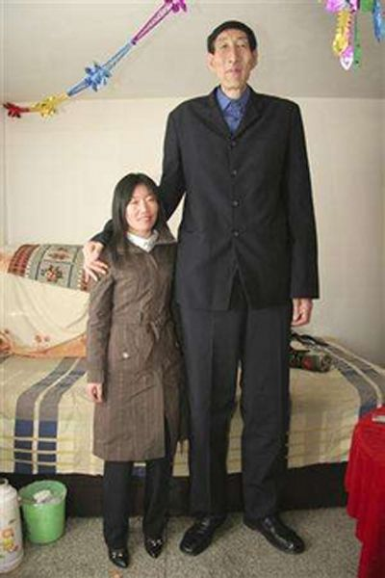 |  | 
The man is …  Laki-lakiinitinggi | The girl is …  Gadis inilangsing | The man is …  Laki-lakiinigemuk
 |  | 
He is …  Dia (laki-laki) sudahtua | She is …  Dia (prm) masihmuda | She is …  Dia (perempuan) cantik

So, you can say about people’s appearance by using some adjectives. From the pictures above, we learn some. They are: tall, slim, fat, old, young, and beautiful.
Jadi, kamubisaberkatatentangpenampilan orang denganmenggunakan kata sifat (adjective). Dari gambar di atas, kitabelajarbeberapa kata sifat, yaitu: tinggi, langsing, gemuk, tua, muda, dan cantik.

You can also say about your appearance and other people from your/their parts of body. For example, hair, skin, face, etc.
Kalian juga bisamengatakanpenampilan kalian dan orang lain berdasarkananggotatubuh, misalkanrambut, kulit, wajah, dan lain-lain.

Types and Length of Hair: Jenis dan panjangrambut
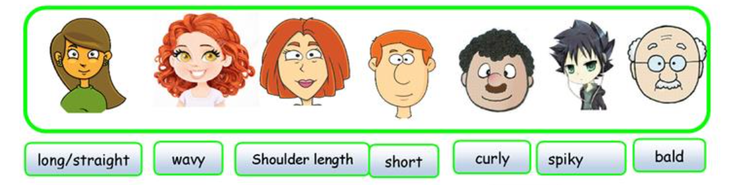
Types of Face: Bentuk wajah
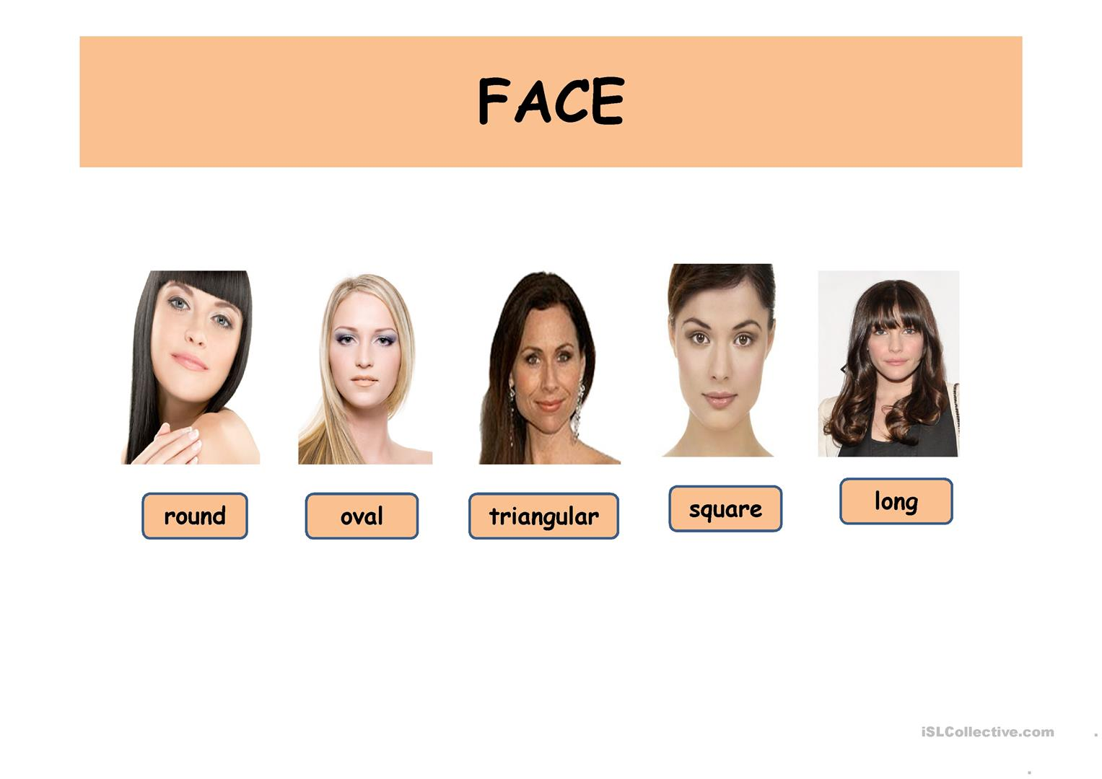
Types of Lips: Bentuk bibir Types of Nose: Bentuk Hidung
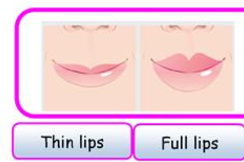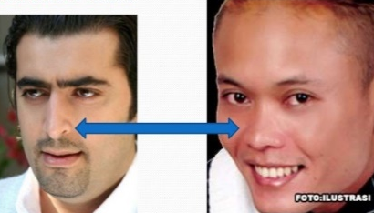
Thin Thick Pointed Flat

Exercise 2 Describe the following pictures Mari berlatih.by using the sentences in the box. You can choose more than one sentence.
(Deskripsikangambar-gambarberikutdengankalimat yang adadalamkotak. Kamubisamemilihlebihdarisatu.)
 |  |  | 
……………………………….  ………………………………. | …………………………..  ………………………….. | …………………………….  ……………………………. | ………………………..  ………………………..

I have straight hair I have dark skin | I have short hair
I have thin lips I have fair skin. | I have long hair
I have thick lips I have pointed nose | I have flat nose

DAYS OF THE WEEK AND MONTHS OF THE YEAR

- STUDY CAREFULLY!
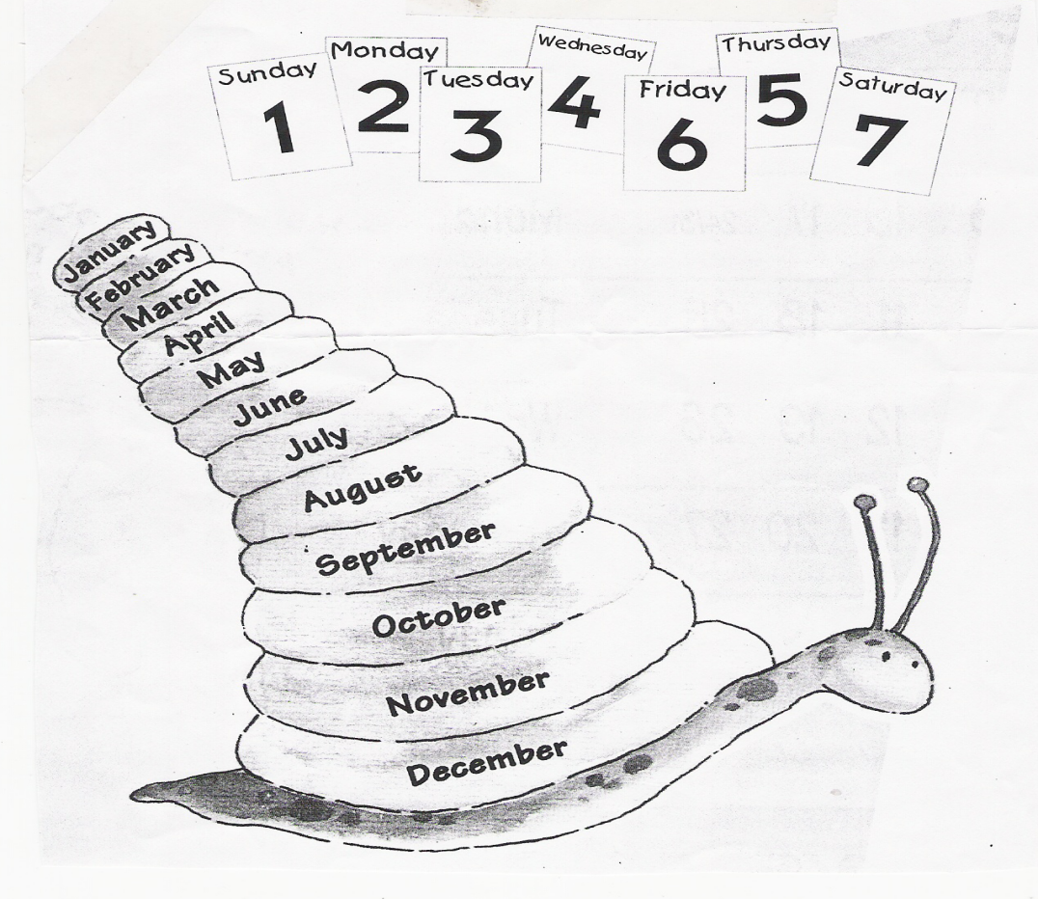

DAYS OF THE WEEK |  | MONTHS OF THE YEAR
SUNDAY  MONDAY  TUESDAY  WEDNESDAY  THURSDAY  FRIDAY  SATURDAY | MINGGU  SENIN  SELASA  RABU  KAMIS  JUMAT  SABTU | JANUARY  FEBRUARY  MARCH  APRIL  MAY  JUNE  JULY  AUGUST  SEPTEMBER  OCTOBER  NOVEMBER  DECEMBER | JANUARI  PEBRUARI  MARET  APRIL  MEI  JUNI  JULI  AGUSTUS  SEPTEMBER  OKTOBER  NOPEMBER  DESEMBER

- EXERCISES (READ AND PRACTISE THESE WORDS BELOW!)
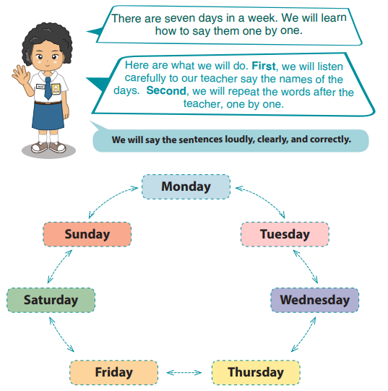

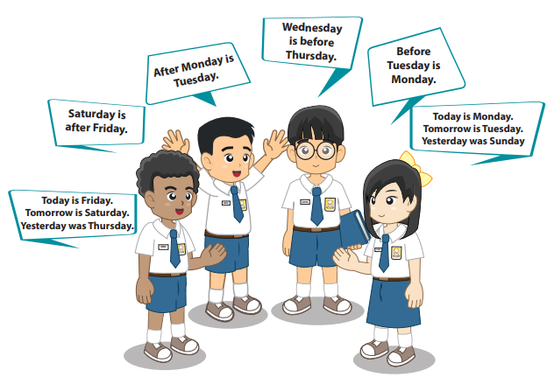
DATES
- Say the numbers
Cardinal Number | Pronunciation | Ordinal Number | Pronunciation
1  2  3  4  5  6  7  8  9  10  11  12  13  14  15  16  17  18  19  20  21  22  23  24  25  26  27  28  29  30  31 | One  Two  Three  Four  Five  Six  Seven  Eight  Nine  Ten  Eleven  Twelve  Thirteen  Fourteen  Fifteen  Sixteen  Seventeen  Eighteen  Nineteen  Twenty  Twenty one  Twenty two  Twenty three  Twenty four  Twenty five  Twenty six  Twenty seven  Twenty eight  Twenty nine  Thirty  Thirty one | 1 ^{st}  2 ^{nd}  3 ^{rd}  4 ^{th}  5 ^{th}  6 ^{th}  7 ^{th}  8 ^{th}  9 ^{th}  10 ^{th}  11 ^{th}  12th  13th  14th  15th  16th  17th  18th  19th  20th  21th  22th  23th  24th  25th  26th  27th  28th  29th  30th  31th | First  Second  Third  Foutth  Fifth  Sixth  Seventh  Eighth  Ninth  Tenth  Eleventh  Twelfth  Thirteenth  Fourteenth  Fifteenth  Sixteenth  Seventeenth  Eighteenth  Nineteenth  Twentieth  Twenty -first  Twenty - second  Twenty - third  Twenty - fourth  Twenty - fifth  Twenty - sixth  Twenty - seventh  Twenty - eighth  Twenty - ninth  Thirtieth  Thirty - first

*NOTE: TO SHOW THE DATE, WE USE ORDINAL NUMBER

2 WAYS TO SAY THE DATE IN ENGLISH
April the twenty first 2021  August the seventeenth 2021  May the second 2021 | the twenty first of April 2021  the seventeenth of August 2021  the second of May 2021

- EXERCISES (READ THESE SENTENCES BELOW LOUDLY!)
- April the twenty first is the Kartini Day.
- April the twenty second is the Earth Day.
- May the first is the Labor Day.
- May the second is the National Education Day.
- May the twentieth is the National Awakening Day.
- May the twenty second is the Reformation
- June the first is the Pancasila Day.
- August the seventeenth is the Independence Day.
- October the second is the Batik Day.
- October the fifth is the Indonesian National Armed Force Day.
- October the twenty eighth is the Youth Pledge Day.
- November the tenth is the Heroes’ Day.
- December the twenty second is the Mother’s Day
TELLING THE TIME

Istilah yang seringmunculdalam Telling the Time
- a.m : ante meridiem (dimulaidari jam 12 malamsampai jam 12 siang)
- p.m : post meridiem (dimulaidari jam 12 siangsampai jam 12 malam)
- Long hand :Jarumpanjang
- Short hand :Jarumpendek
- Second hand :Jarumdetik
- Hour : Jam
- Minute :Menit
- Second :Detik
- Past :Lebih
- To : Kurang
- A quarter :Seperempat (15 menit)
- A half :Setengah (30 menit)
Untukmembaca jam dalambahasainggrissilahkanlihatgambar di bawahini:
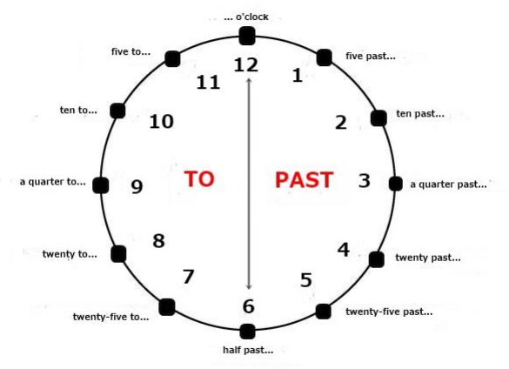

Umumnyaadaduarumusuntukmenyatakan jam yaitu:

- Jam + Menit
Cara inimerupakancara yang paling mudahuntukmenunjukanwaktu, hanyadibacakansajaangkanyadalambahasainggris.
Contoh:
03.30 = It's three thirty (Itu jam tigatigapuluh)
06.45 = It's six forty-five (ituenamempatpuluh lima)
- Minutes + past/to +hour
Pada carainikitaharusmenyebutkanmenit-nyadulu, setelahitubaru jam-nya dan memakai kata 'past' untukmenyatakanlebihatau 'to' untukmenyatakankurangnyamenit pada jam tersebut.
Contoh:
08.10 = It's ten past eight (Itu jam delapanlewatsepuluhmenit)
08.55 = It's five (minutes) to nine (lima menitlagimenuju jam sembilan/ jam sembilankurang lima menit)

Untukmembaca jam adabeberapahal yang haruskitaperhatikan.

- Jam tepat = Jika jam menunjukkan jam tepat/pas (jarumpanjangtepatkeangka 12) makakitabisamengucapkannyasepertiberikut:
It's seven o'clock. (Jam tujuhtepat 07.00)
It's nine o'clock. (Jam sembilantepat/ 09.00)
It's eleven o'clock. (Jam sebelastepat/ 11.00)

- Jam lebih = Jika jarumpanjang jam menunjukkanlebih 1-30 menit, makakitaharusmengatakan:
It's ten minutes past nine. (Jam 8 lebihsepuluhmenit/ 08.10)
It's a quarter past eleven. (Jam sebelaslebih lima belasmenit/ 11.15)
It's a half past twelve. (Jam duabelaslebihtigapuluhmenit/ setengahsatu / 12.30)
- Jam kurang = Jika jarumpanjangmenunjukkanlebihdari 31 menitkeatas, makakitaharusmengatakan:
It's ten to nine. (Jam sembilankurangsepuluhmenit/ 09.50)
It's five to three. (Jam tigakurang lima menit/ 02.55)
It's a quarter to five. (Jam lima kurang lima belasmenit/ 04.45)

